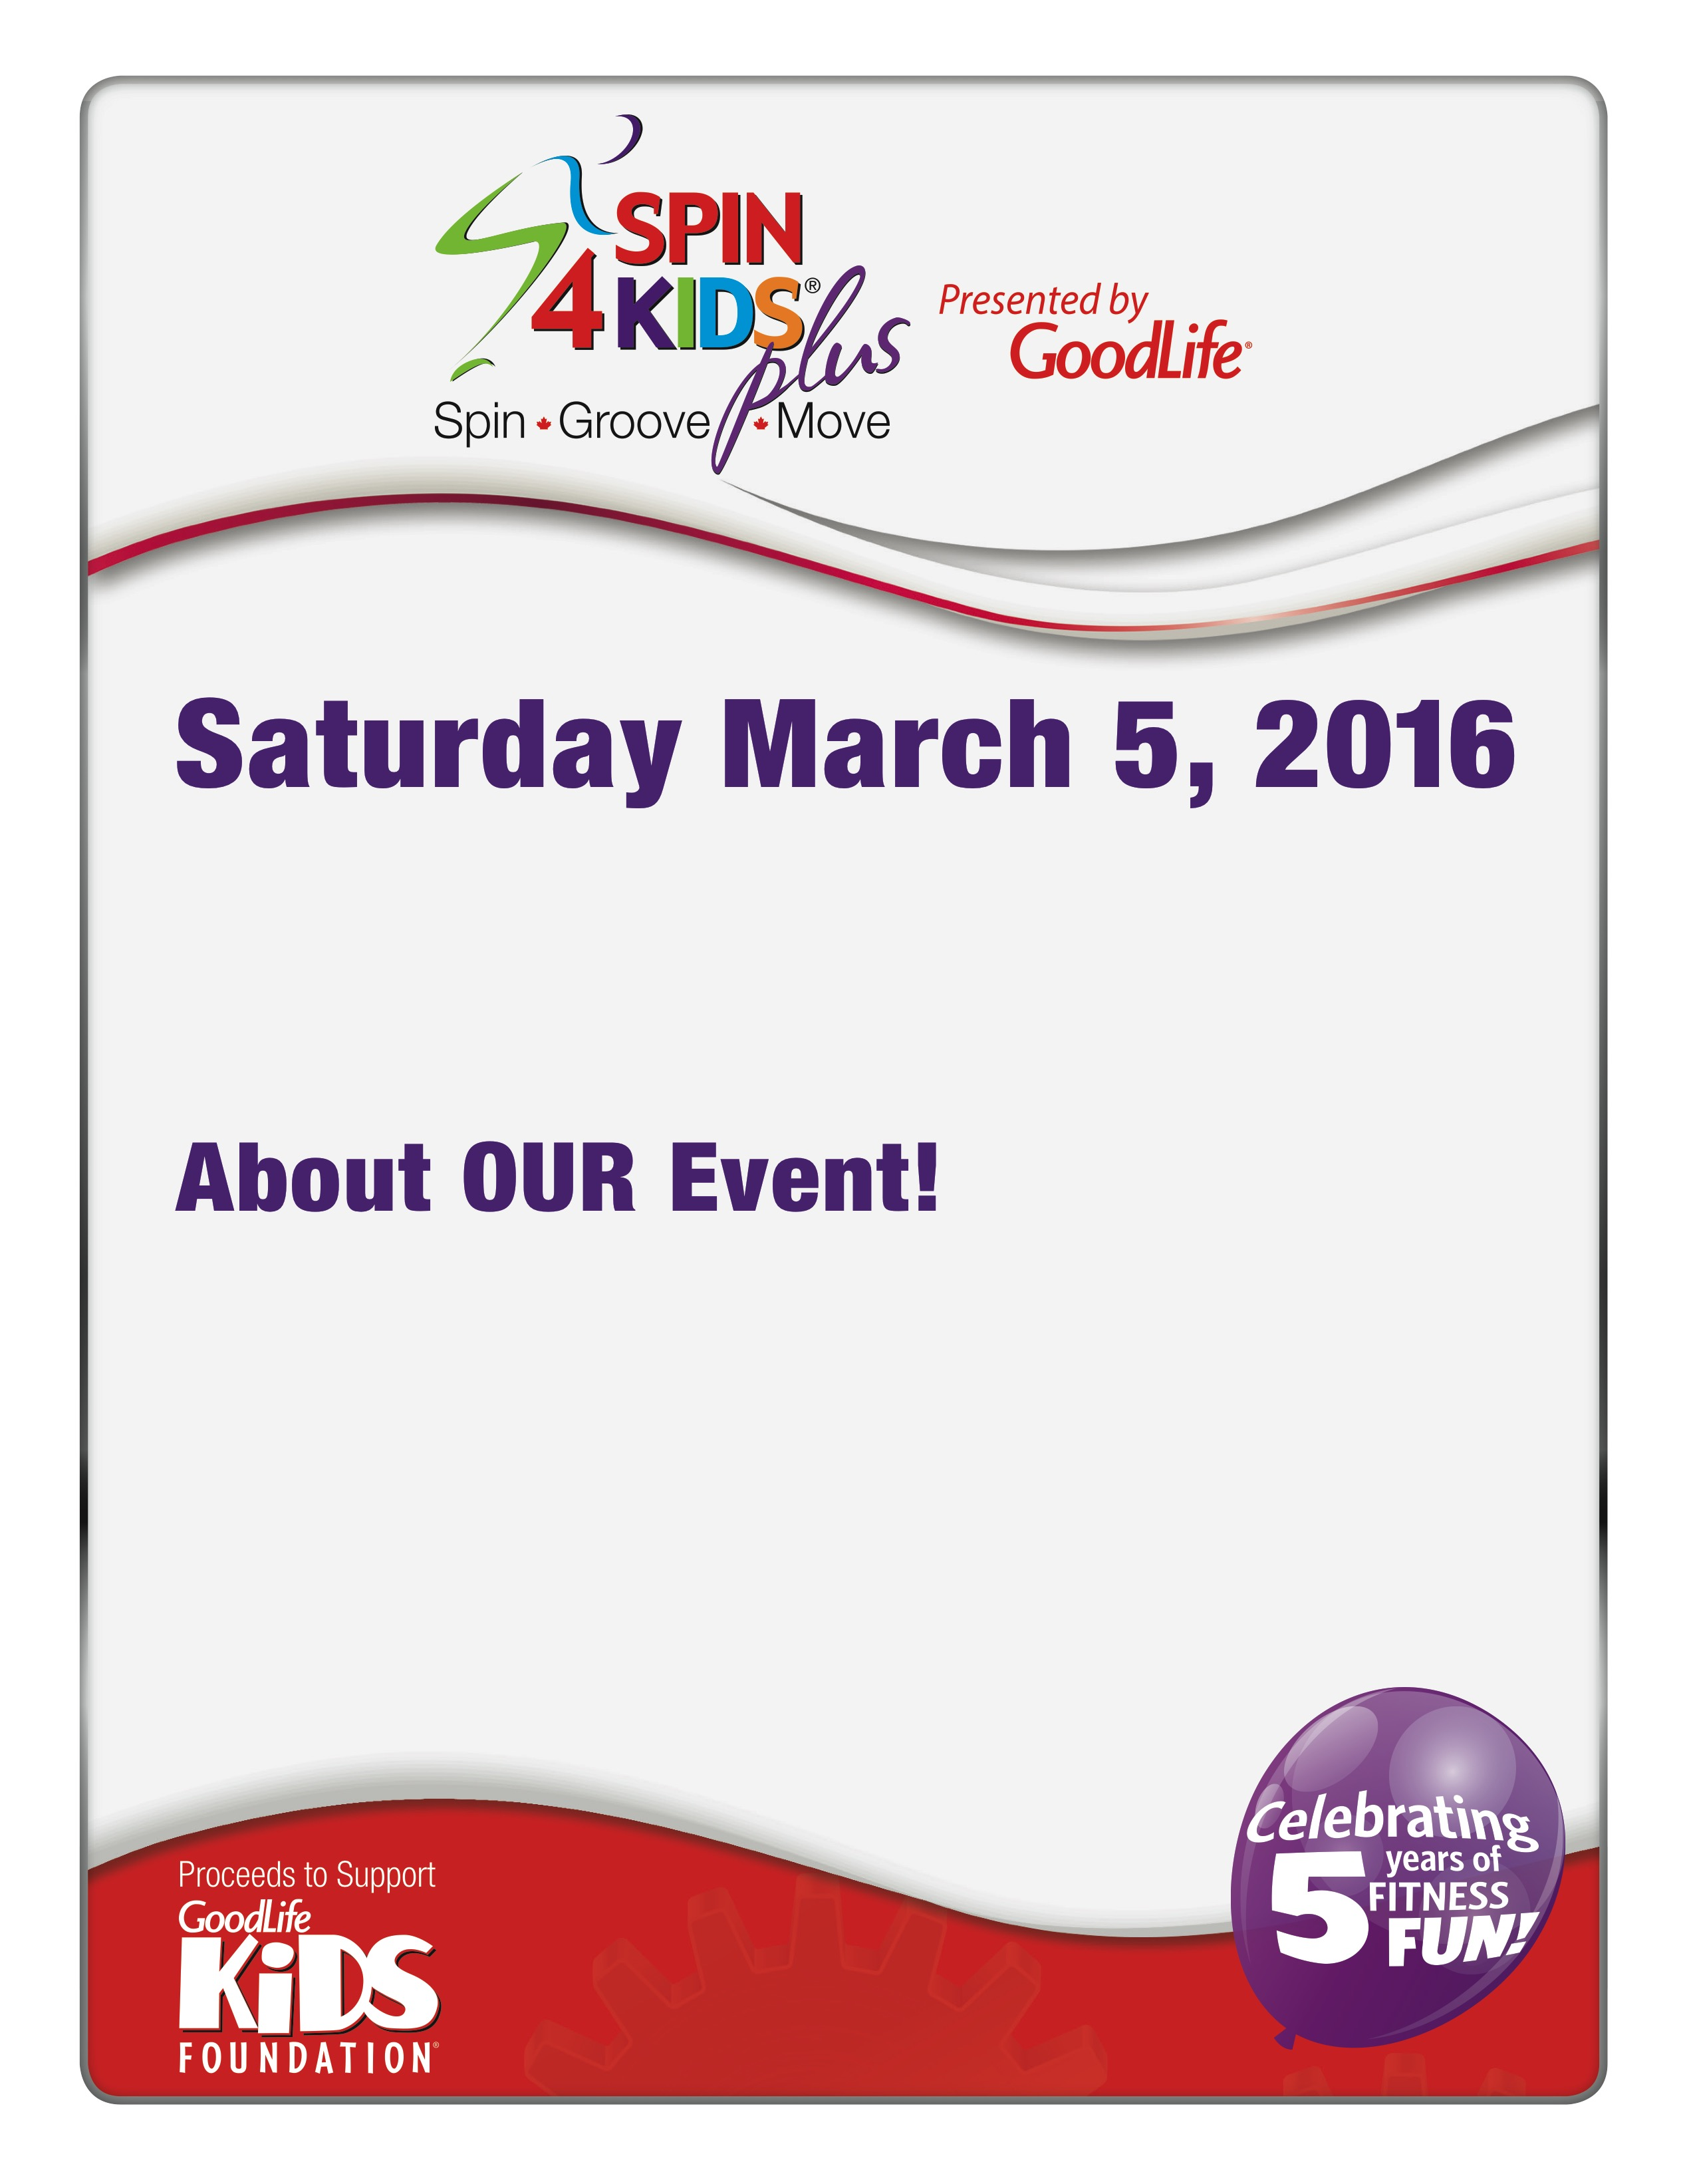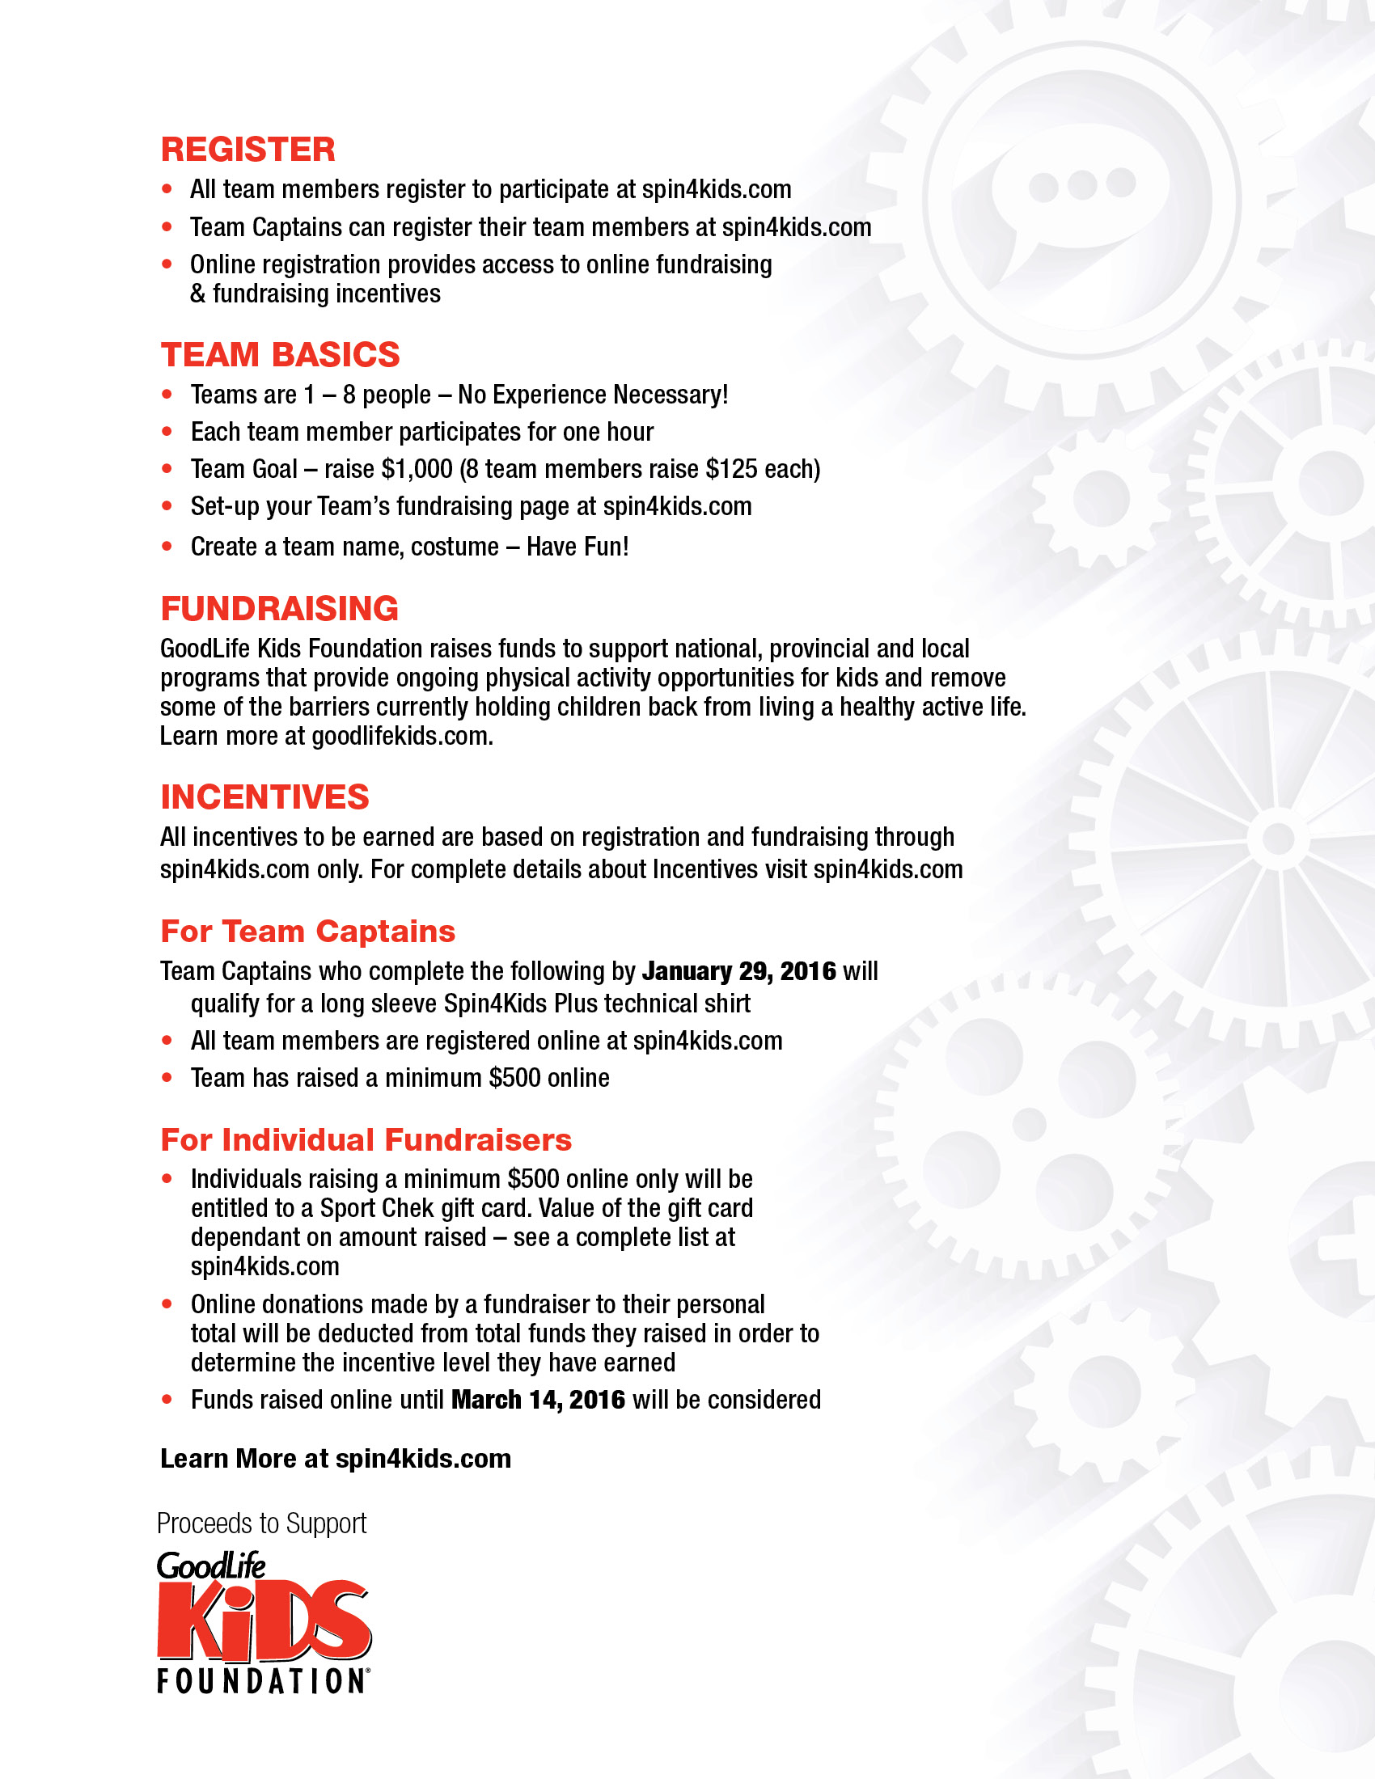

Copy goes here

Location: Place goes here

Time: 00:00

Event Contact: Name Here

Contact Email: email