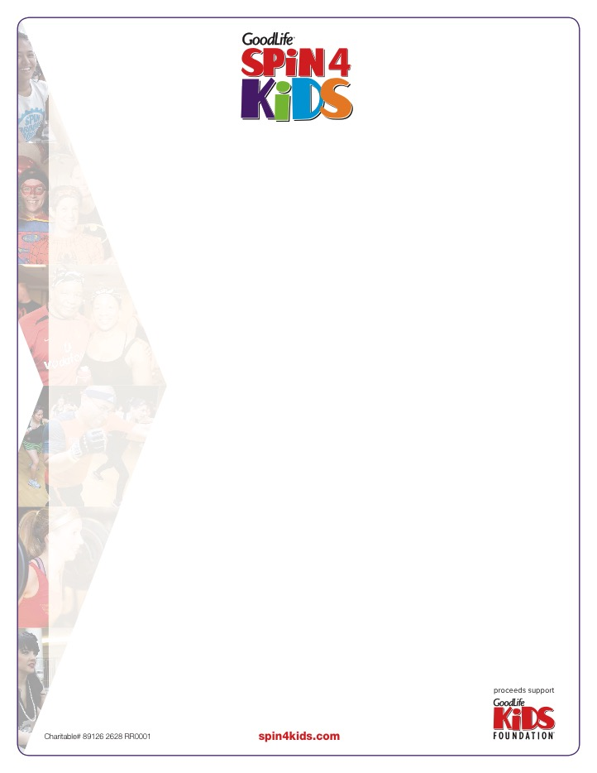­­­

**Event Day Materials**

All items will arrive in HOST CLUBS by February 20th

|  |  |
| --- | --- |
| **Shipping From New Era Grafix** | **Shipping From Sportswood Printing** |
| * 2017 *Spin4Kids* participant t-shirts * *Spin4Kids* Balloons * Team Buffs | * National Sponsor Recognition signs * GLKF Informational Signs * Photo Booth props |

**2017 *Spin4Kids* Participant T-shirts**

* All participants will receive a *Spin4Kids Plus* t-shirt.
* Participants who registered online by January 30th have been guaranteed their preferred size and style of shirt. You will receive a report listing specific participants and the type/size of shirt they are to receive upon arrival.
* Both unisex and ladies t-shirts are provided

**How to distribute shirts to participants when they check in**

* Use the ‘Spin4Kids-Participant shirt’ spreadsheet to set aside t-shirts for anyone who was guaranteed their size/style. *This should be done before any shirts are given to Event Leaders, Volunteers, Instructors etc.*
* Identify participants with a guaranteed t-shirt on all copies of your participants list that will be used at your check in desk
* When these participants arrive, ensure they are given the shirt(s) they’ve requested
* All other participants will receive sizes and styles on a first come, first served basis.
* Any shirts left over after the event can be kept at the club for member referrals etc. DO NOT SHIP THESE BACK TO GOODLIFE KIDS FOUNDATION OR NEW ERA GRAFIX

**Team Buffs**

* Teams who have raised $1000 qualify to receive a team set of Buffs.
* Any donations that have been made by a participant to themselves must be deducted, as per Canada Revenue Agency.

**How to distribute buffs to participants when they check in**

* + Prepare team totals ahead of event day with
  + As teams check-in and submit their pledge forms, cash, and cheques, keep a running total for each team
  + Add in any online donations already submitted for each team (this can be done pre-event)
  + **Remove any personal donations**
  + Once the whole team has arrived and checked-in, if their total is $1000 or more (minus any personal donations) give a team set of buffs to the Team Captain to distribute for their team to wear during their activity.
  + Any Buffs left over after the event can be kept at the club for member referrals etc. DO NOT SHIP THESE BACK TO GOODLIFE KIDS FOUNDATION OR NEW ERA GRAFIX

*Please see page 2 for instructions on your *Spin4Kids* Balloons and event signage

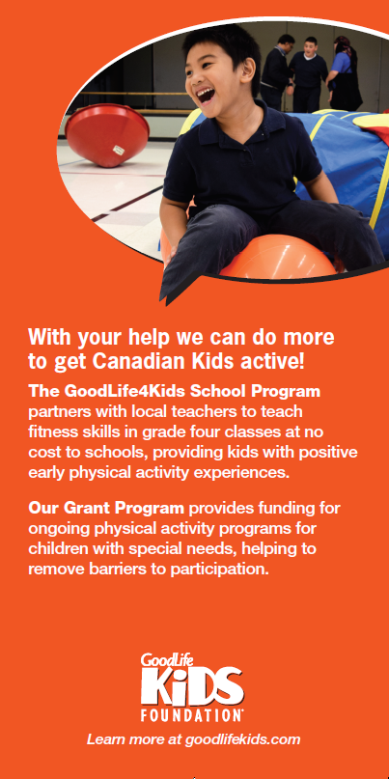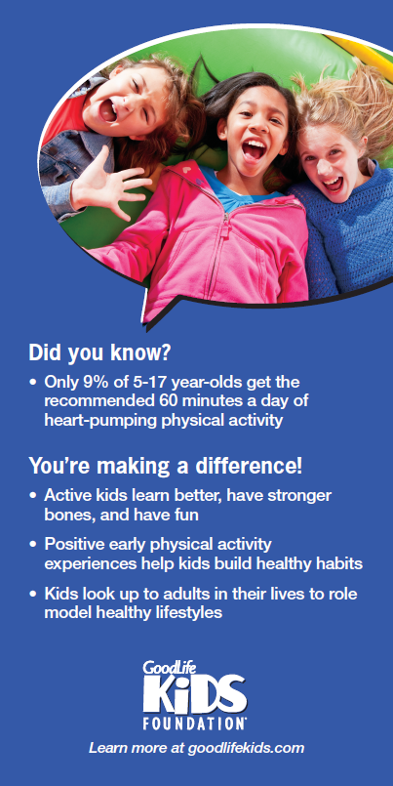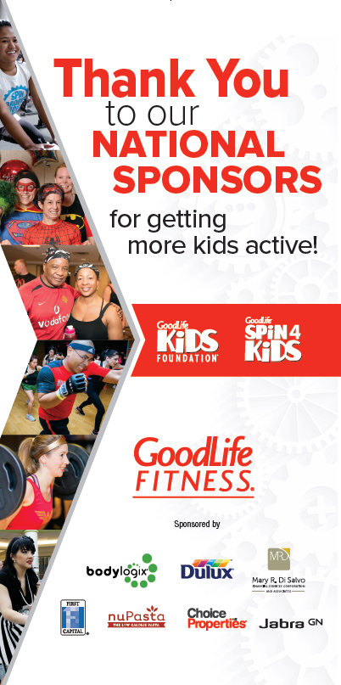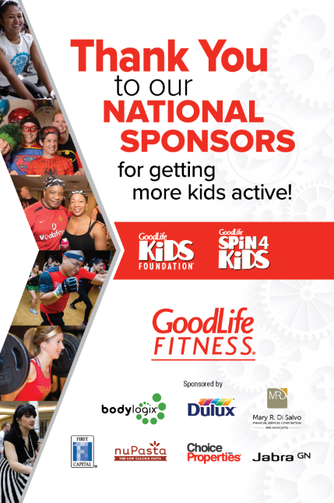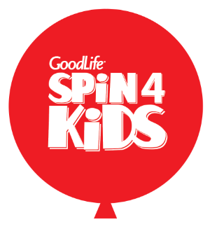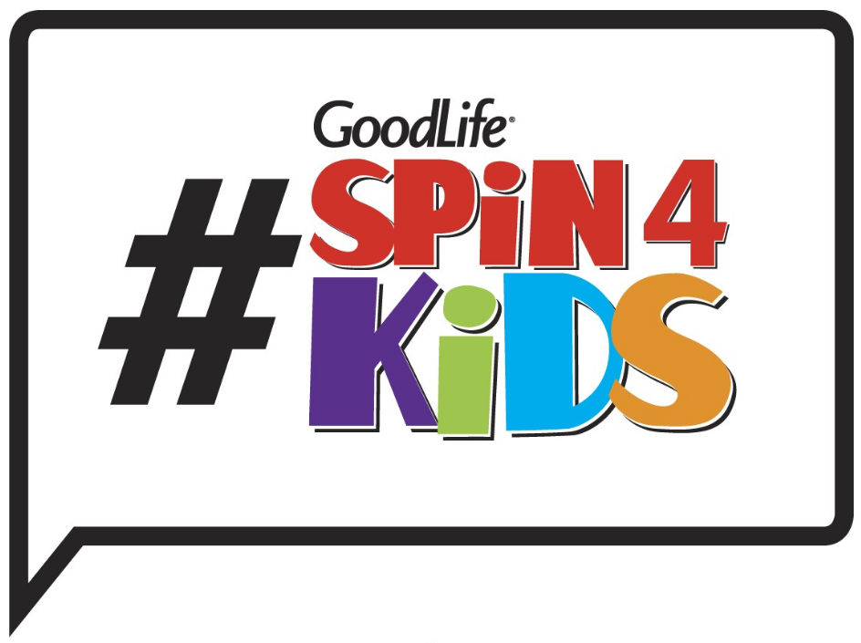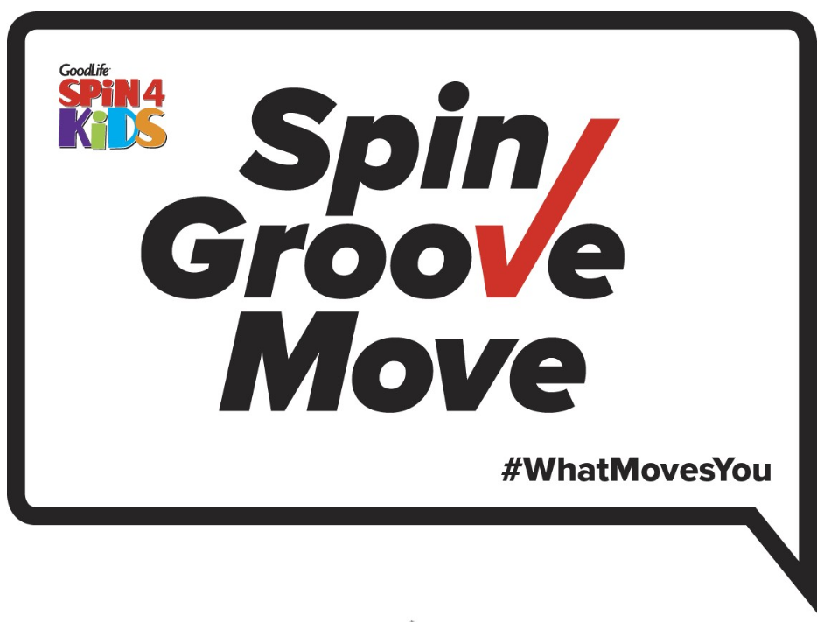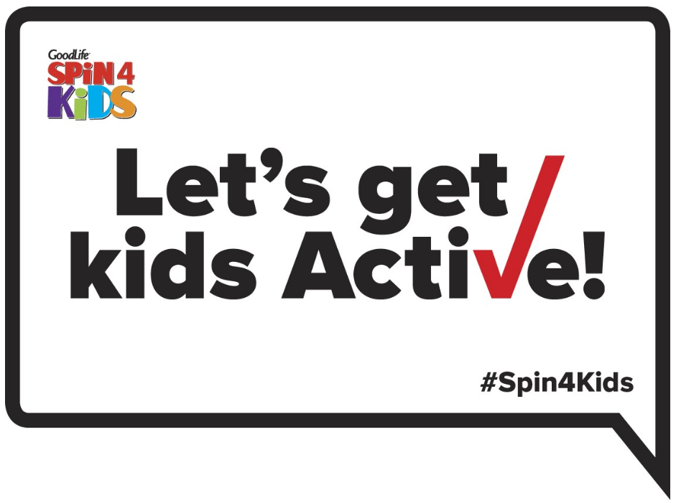 

**GLKF Information Signs (Set of 3)**

These three informational signs should be placed in prominent areas around your event so participants and members can see how their support is *Spin4Kids* helps GLKF get kids active.

Here are some ideas of where to place the signs:

* Studio entrances
* Front Desk
* Check in Desk
* Use clear packing tape to secure into a triangle and place in high traffic area of club (could place a bunch or balloons in the middle to highlight)

*Don’t place on the stage as participants won’t be able to read them there

**National Sponsor Recognition Signs (Set of 2)**

This year we have two sizes of signs for you. A smaller table top sign and a larger floor standing sign. Please display the National Sponsor recognition signs on your check-in desk and other high traffic area so that participants can see who is supporting *Spin4Kids* 2017

**Spin4Kids Balloons**

You’ve been sent a selection of foil balloons to help create a party atmosphere for your event

* 6x Round Red with Spin4Kids logo
* 6x Round Purple Spin Groove Move
* 8x Silver stars (blank)

Here’s how to prepare them for your event:

* Visit your local party store to have them inflated with helium
* Talk to the party store about donating the helium, string and weights - a donation request letter can be found on the Event Portal
* Ask for the balloons to be arranged into bunches of 5 - you have enough balloons for 4 bunches

How to use them:

* To highlight the entrance to your event space
* Draw attention to refreshment or prize table
* Decorate the stage around your instructors
* Highlight your check-in desk

**Photo Booth Props (Set of 3)**

New this year!

* Set-up a photo booth area to take fun pictures of participants at your event
* Post photos on Facebook, Twitter & Instagram –   
  use #spin4kids and @GoodLifeKids